



# Incident Response Platform Integrations

# BigFix Function V1.0.0

Release Date: Aug 2018

Resilient Functions simplify development of integrations by wrapping each activity into an individual workflow component. These components can be easily installed and then used and combined in Resilient workflows. The Resilient platform sends data to the function component that performs an activity and then returns the results to the workflow. The results can be actioned by scripts, rules, and workflow decision points to dynamically orchestrate the security incident response activities.

This guide describes the BigFix Integration Function.

Overview

BigFix is an endpoint management tool that allows users to keep systems or endpoints in an environment under its control, updated, compatible and free of security issues. It allows for the identification and remediation of a vulnerable endpoint from a central console.

The BigFix integration with the Resilient platform allows querying of a BigFix environment using the REST APIs, where the returned results can be used to remediate issues or hits, such as a malicious path or filename, a service or process name, or a registry key.

The four functions supplied in this Resilient package support the following use cases.

* Beginning with an Indicator of Compromise (IOC) such as a malicious path or filename, service or process name, registry key, or IP address, the BigFix integration allows you to search a BigFix environment for all affected endpoints with a hit, and then update a data table with this information where it can be displayed on the Resilient platform.
* Allows you to query BigFix for all available BigFix properties of an endpoint with a hit, and then attach an XML file with these properties to the Resilient incident.
* Allows you to execute BigFix remediation procedures from the Resilient platform against an endpoint with a hit. These procedures include killing a process, stopping a service, deleting a registry key (Microsoft Windows only) or a file.
* Allows you to query and update the status of a BigFix remediation action from the Resilient platform on an endpoint with a hit.

The remainder of this document describes the included Functions, how to configure example custom workflows, and any additional customization options.

Installation

Before installing, verify that your environment meets the following prerequisites:

* BigFix version must be 9.5 patch 2, or later.
* Resilient platform must be version 30 or later.
* A designated BigFix Console Operator account, with the Create Custom Content permission enabled. This account must be configured to access all those endpoints that you wish to have accessible to the Resilient platform.
* You must have a Resilient account to use for the integrations. This can be any account that has the permission to view and modify administrator and customization settings, and read and update incidents. You must know the account username and password.
* You have access to the command line of the Resilient appliance, which hosts the Resilient platform; or to a separate integration server where you will deploy and run the functions code. If you are using a separate integration server, you must install Python version 2.7.10 or later, or version 3.6 or later, and “pip”. (The Resilient appliance is preconfigured with a suitable version of Python.)

Install the Python components

The functions package contains Python components that are called by the Resilient platform to execute the functions during your workflows. These components run in the resilient-circuits integration framework.

The package also includes Resilient customizations that will be imported into the platform later.

Complete the following steps to install the Python components:

1. Ensure that the environment is up-to-date, as follows:

sudo pip install --upgrade pip

sudo pip install --upgrade setuptools

sudo pip install --upgrade resilient-circuits

1. Run the following command to install the package:

sudo pip install --upgrade fn_cisco_umbrella_inv-1.0.0.tar.gz

Configure the Python components

The resilient-circuits components run as an unprivileged user, typically named integration. If you do not already have an integration user configured on your appliance, create it now.

Complete the following steps to configure and run the integration:

1. Using sudo, switch to the integration user, as follows:

sudo su - integration

1. Use one of the following commands to create or update the resilient-circuits configuration file. Use –c for new environments or –u for existing environments.

resilient-circuits config -c

or

resilient-circuits config -u

1. Edit the resilient-circuits configuration file, as follows:
   1. In the [resilient] section, ensure that you provide all the information required to connect to the Resilient platform.
   2. In the [fn_bigfix] section, edit the settings as follows:

bigfix_url. URL of your BigFix server; for example: <https://bigfix-url.com>

bigfix_port. Port number of your BigFix server.

bigfix_user. Username of the BigFix Console Operator account used for this integration.

bigfix_pass. Password for the BigFix Console Operator account.

bigfix_polling_interval. Time in seconds that the integration waits between polling BigFix to get the final status of the remediation actions. Default is 30

bigfix_polling_timeout. Time in seconds that the integration waits before timing out while polling BigFix to get the final status of the remediation actions. Default is 1800

hunt_results_limit. Limits the number of results sent to the Resilient platform. Default is 200.

Deploy customizations to the Resilient platform

The package contains function definitions that you can use in workflows, and includes example workflows and rules that show how to use these functions.

1. Use the following command to deploy these customizations to the Resilient platform:

resilient-circuits customize

1. Respond to the prompts to deploy functions, message destinations, workflows and rules.

Run the integration framework

To test the integration package before running it in a production environment, you must run the integration manually, using the following command:

resilient-circuits run

…

2018-08-01 16:49:02,931 INFO [app] Configuration file:

2018-08-01 16:49:02,932 INFO [app] Resilient server: <host>

2018-08-01 16:49:02,933 INFO [app] Resilient user: <acct>

2018-08-01 16:49:02,933 INFO [app] Resilient org: <org>

2018-08-01 16:49:02,934 INFO [app] Logging Level: INFO

…

2018-08-01 16:49:03,431 INFO [component_loader] Loading 4 components

2018-08-01 16:49:03,432 INFO [component_loader] 'fn_bigfix.components.fn_bigfix_assets.FunctionComponent' loading

2018-08-01 16:49:03,434 INFO [component_loader] 'fn_bigfix.components.fn_bigfix_artifact.FunctionComponent' loading

2018-08-01 16:49:03,435 INFO [component_loader] 'fn_bigfix.components.fn_bigfix_action_status.FunctionComponent' loading

2018-08-01 16:49:03,437 INFO [component_loader] 'fn_bigfix.components.fn_bigfix_remediation.FunctionComponent' loading

…

2018-08-01 16:49:03,451 INFO [actions_component] 'fn_bigfix.components.fn_bigfix_assets.FunctionComponent' function 'fn_bigfix_assets' registered to 'bigfix_asset'

2018-08-01 16:49:03,452 INFO [actions_component] 'fn_bigfix.components.fn_bigfix_artifact.FunctionComponent' function 'fn_bigfix_artifact' registered to 'bigfix_artifact'

2018-08-01 16:49:03,453 INFO [actions_component] 'fn_bigfix.components.fn_bigfix_action_status.FunctionComponent' function 'fn_bigfix_action_status' registered to 'bigfix_remediation'

2018-08-01 16:49:03,453 INFO [app] App Started

2018-08-01 16:49:03,455 INFO [actions_component] 'fn_bigfix.components.fn_bigfix_remediation.FunctionComponent' function 'fn_bigfix_remediation' registered to 'bigfix_remediation'

2018-08-01 16:49:03,456 INFO [app] Components loaded

…

2018-08-01 16:49:03,794 INFO [actions_component] Subscribe to message destination 'bigfix_remediation'

2018-08-01 16:49:03,795 INFO [actions_component] Subscribe to message destination 'bigfix_asset'

2018-08-01 16:49:03,796 INFO [actions_component] Subscribe to message destination 'bigfix_artifact'

2018-08-01 16:49:03,797 INFO [stomp_component] Subscribe to message destination actions.202.bigfix_remediation

2018-08-01 16:49:03,798 INFO [stomp_component] Subscribe to message destination actions.202.bigfix_asset

2018-08-01 16:49:03,799 INFO [stomp_component] Subscribe to message destination actions.202.bigfix_artifact

The resilient-circuits command starts, loads its components, and continues to run until interrupted. If it stops immediately with an error message, check your configuration values and retry.

Configure Resilient Circuits for restart

For normal operation, Resilient Circuits must run continuously. The recommended way to do this is to configure it to automatically run at start up. On a Red Hat appliance, you can do this using a systemd unit file such as the one below. You might need to change the paths to your working directory and app.config.

1. The unit file must be named resilient_circuits.service To create the file, enter the following command:

sudo vi /etc/systemd/system/resilient_circuits.service

1. Add the following contents to the file and change as necessary:

[Unit]  
Description=Resilient-Circuits Service  
After=resilient.service  
Requires=resilient.service

[Service]  
Type=simple  
User=integration  
WorkingDirectory=/home/integration  
ExecStart=/usr/local/bin/resilient-circuits run  
Restart=always  
TimeoutSec=10  
Environment=APP_CONFIG_FILE=/home/integration/.resilient/app.config  
Environment=APP_LOCK_FILE=/home/integration/.resilient/resilient_circuits.lock

[Install]  
WantedBy=multi-user.target

1. Ensure that the service unit file is correctly permissioned, as follows:

sudo chmod 664 /etc/systemd/system/resilient_circuits.service

1. Use the systemctl command to manually start, stop, restart and return status on the service:

sudo systemctl resilient_circuits [start|stop|restart|status]

You can view log files for systemd and the resilient-circuits service using the journalctl command, as follows:

sudo journalctl -u resilient_circuits --since "2 hours ago"

Function Descriptions

Once the function package deploys the functions, you can view them in the Resilient platform Functions tab, as shown below. The package also includes example workflows and rules that show how the functions can be used. You can copy and modify these workflows and rules for your own needs.

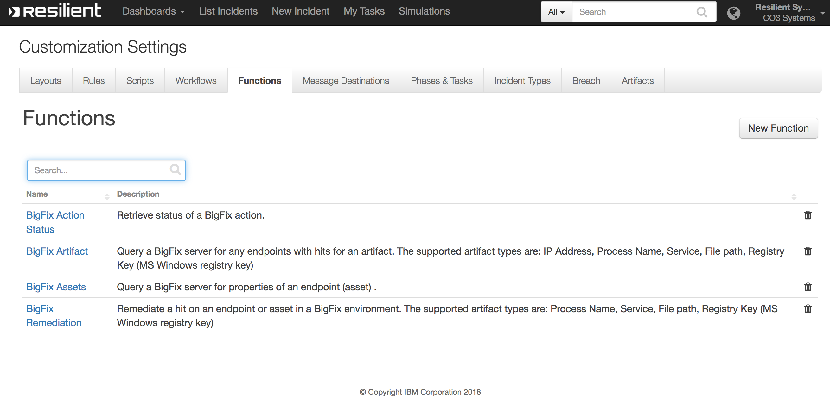

Customizations

In the Customization Settings section of the Resilient platform, you can verify that the following BigFix specific functions, workflows, data-table, and rules are available in the Resilient platform by clicking their respective tabs.

BigFix Artifact

This function performs a query that retrieves a list of endpoints with hits from a BigFix environment.

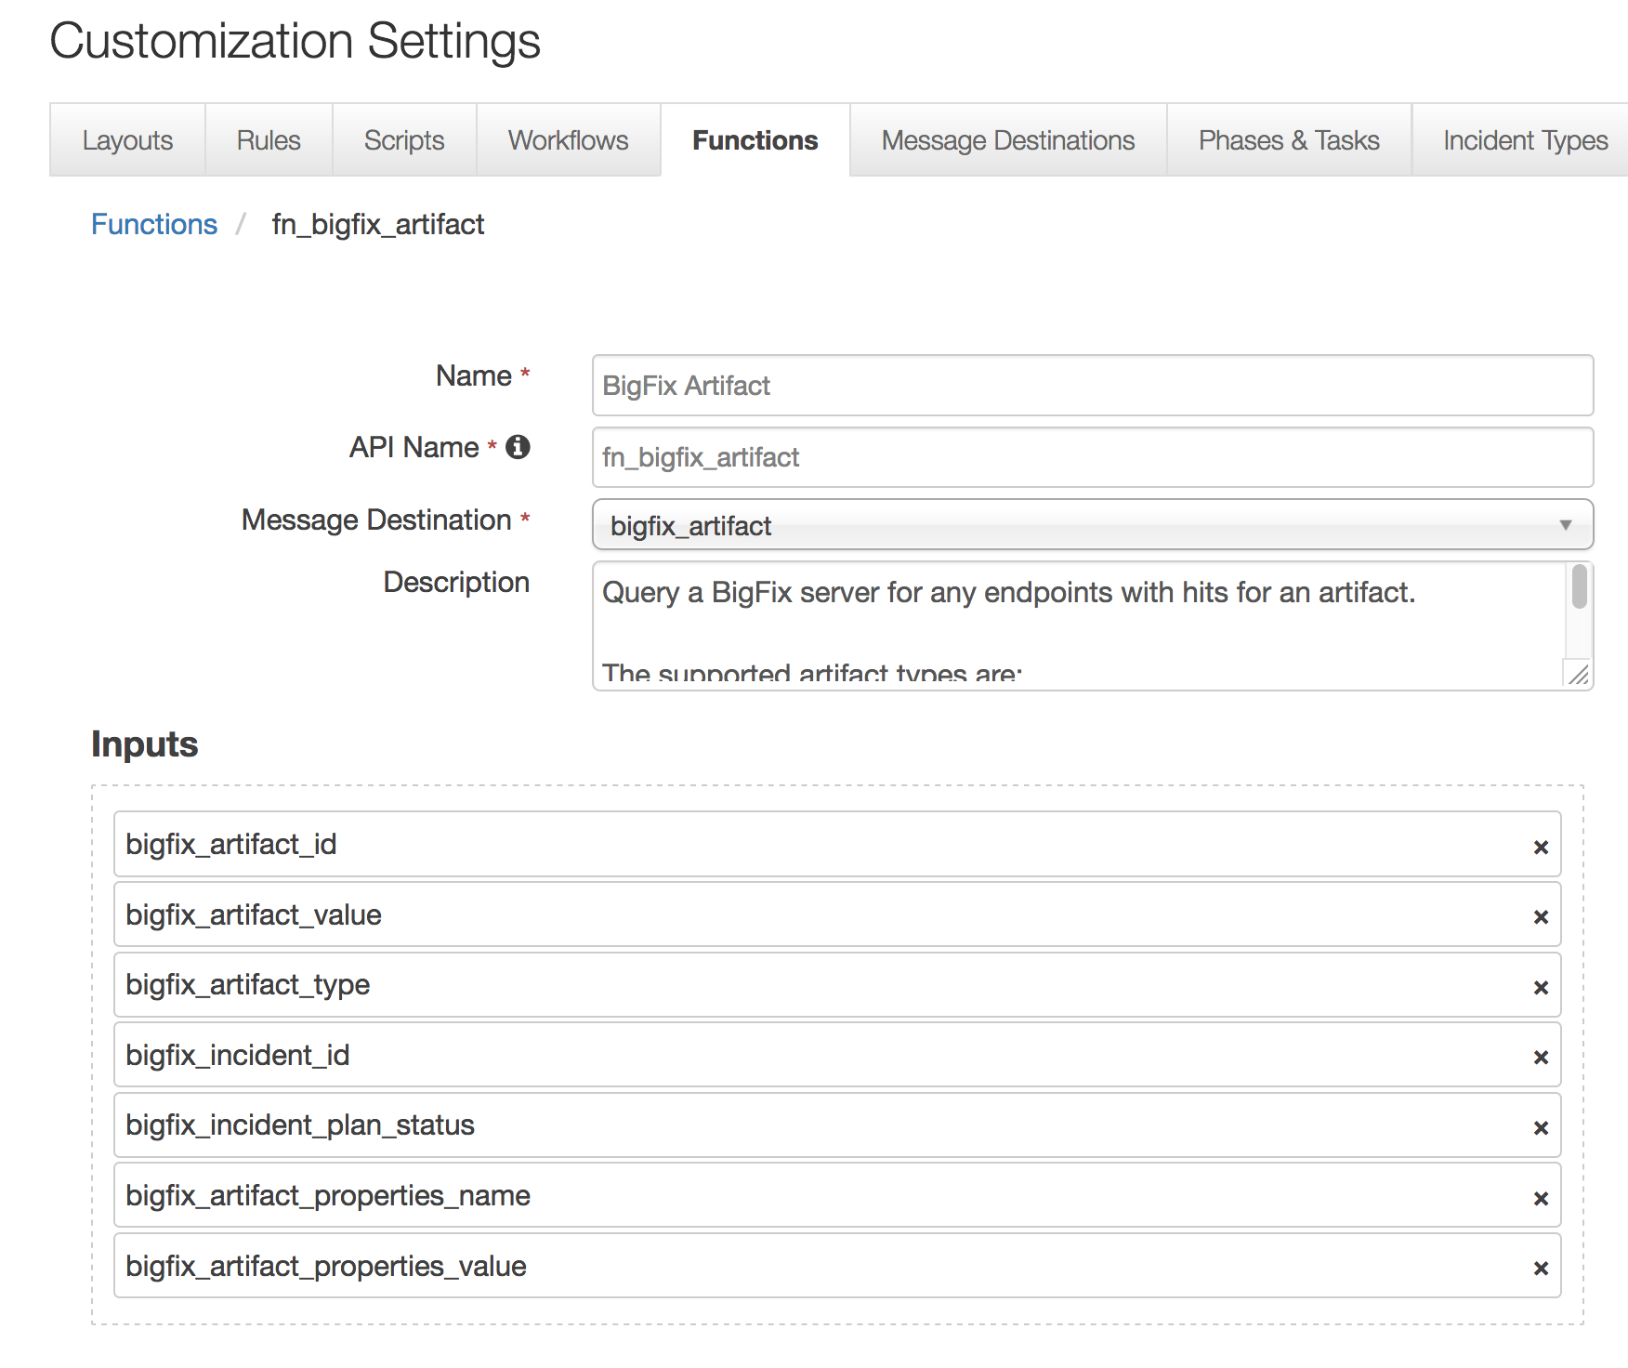

This function takes the following parameters:

* bigfix_artifact_id - Resilient artifact ID
* bigfix_artifact_value - Resilient artifact value
* bigfix_artifact_type - Resilient artifact type
* bigfix_incident_id - Resilient incident ID
* bigfix_incident_plan_status - Resilient incident status
* bigfix_artifact_properties_name - Resilient artifact properties name; optional, used for registry key value name (MS Windows)
* bigfix_artifact_properties_value - Resilient artifact properties name; optional, used for registry key value data (MS Windows)

The example workflow (object type = Artifact) that calls this function is “Query BigFix for Artifact”.

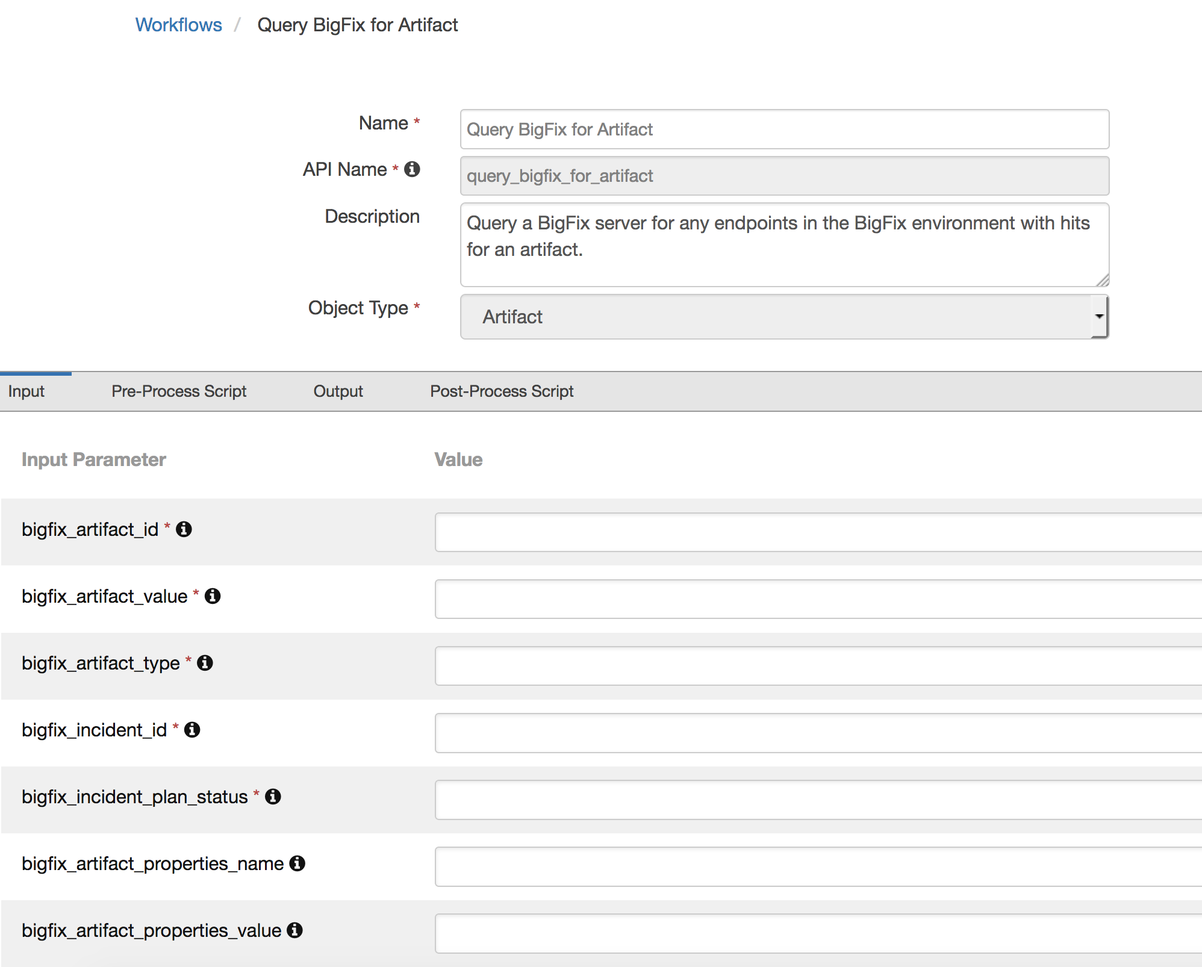

The parameter assignments are done in the Pre-Process Script tab.

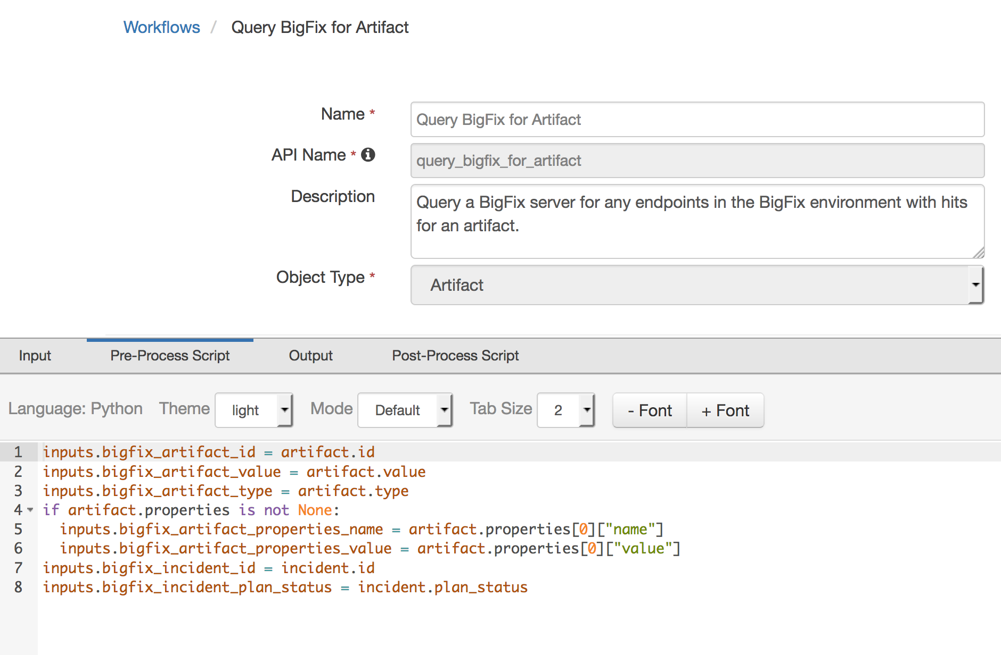

A Menu Item rule called “Query BigFix for Artifact” is also included. This rule calls the workflow above. A user can invoke the workflow by right-clicking on this rule from the Actions drop-down menu of a suspect artifact.

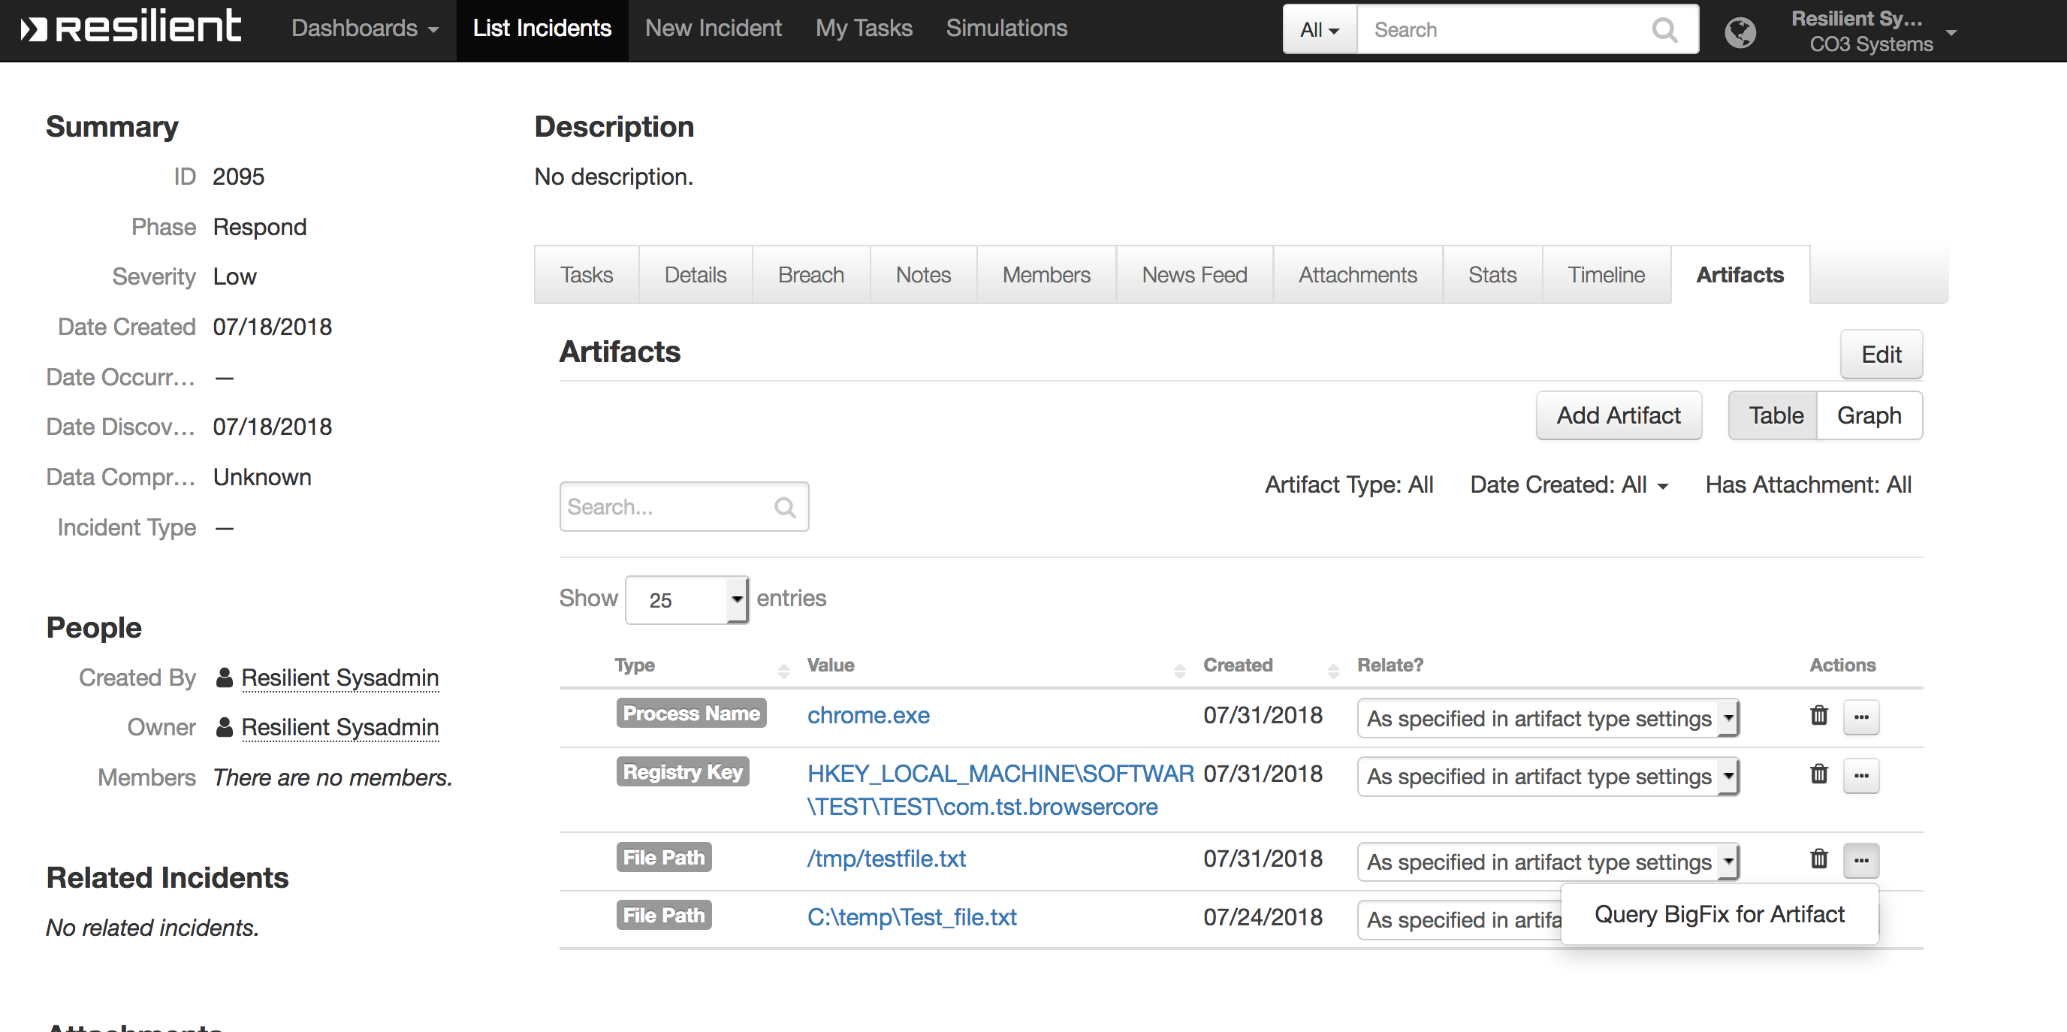

If any endpoints are detected in the BigFix environment with the suspected artifact, entries are added to the data table “BigFix Query Results”.

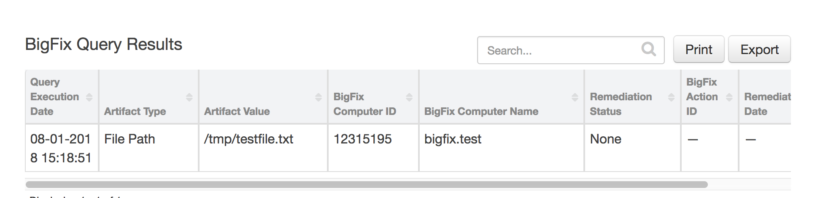

BigFix Remediation

This function creates a BigFix action to remediate a hit found on an endpoint in the BigFix environment.

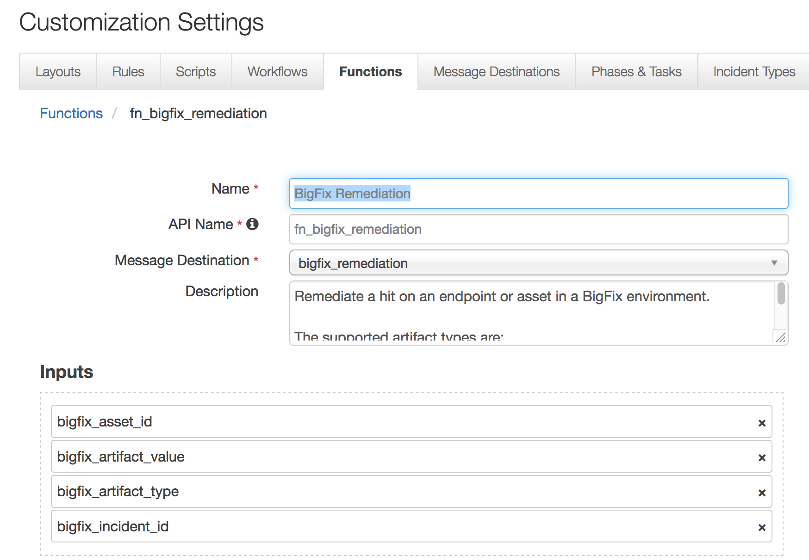

This function takes the following parameters:

* bigfix_asset_id – Bigfix endpoint or asset ID
* bigfix_artifact_value - Resilient artifact value
* bigfix_artifact_type - Resilient artifact type
* bigfix_incident_id - Resilient incident ID
* The example workflow (object type = Data Table) that calls this function is “BigFix Remediate”.

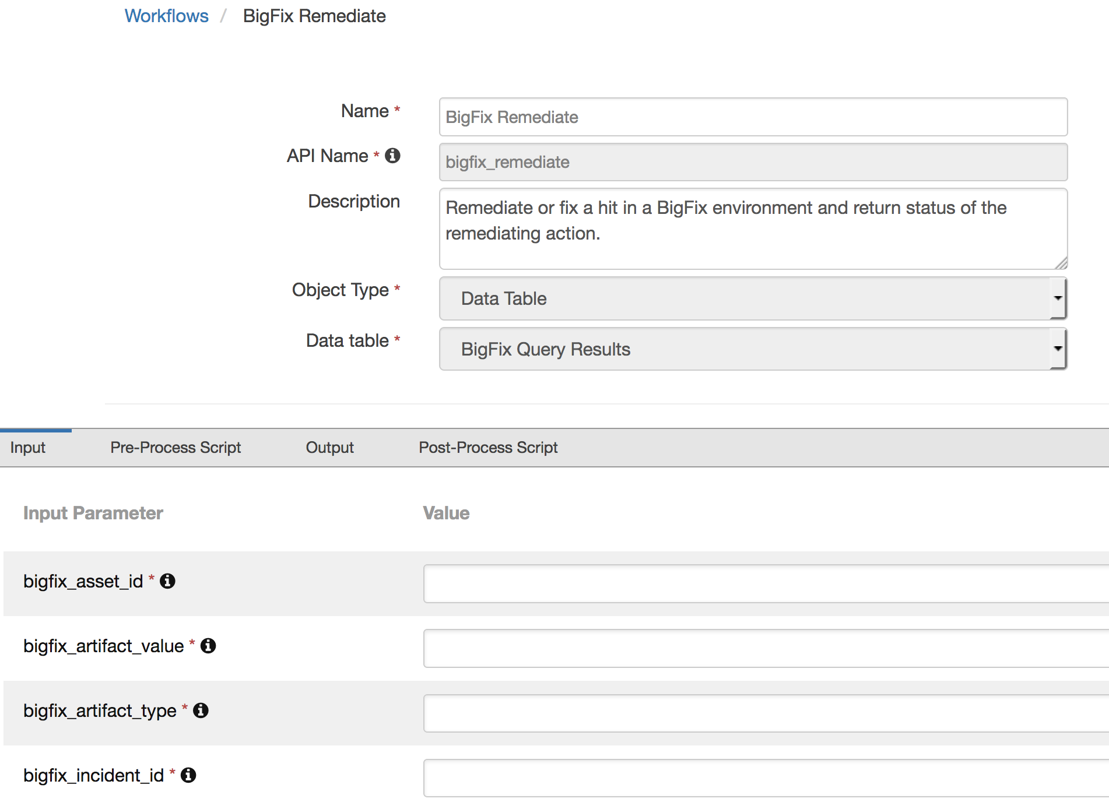

The parameter assignments are done in the Pre-Process Script tab.

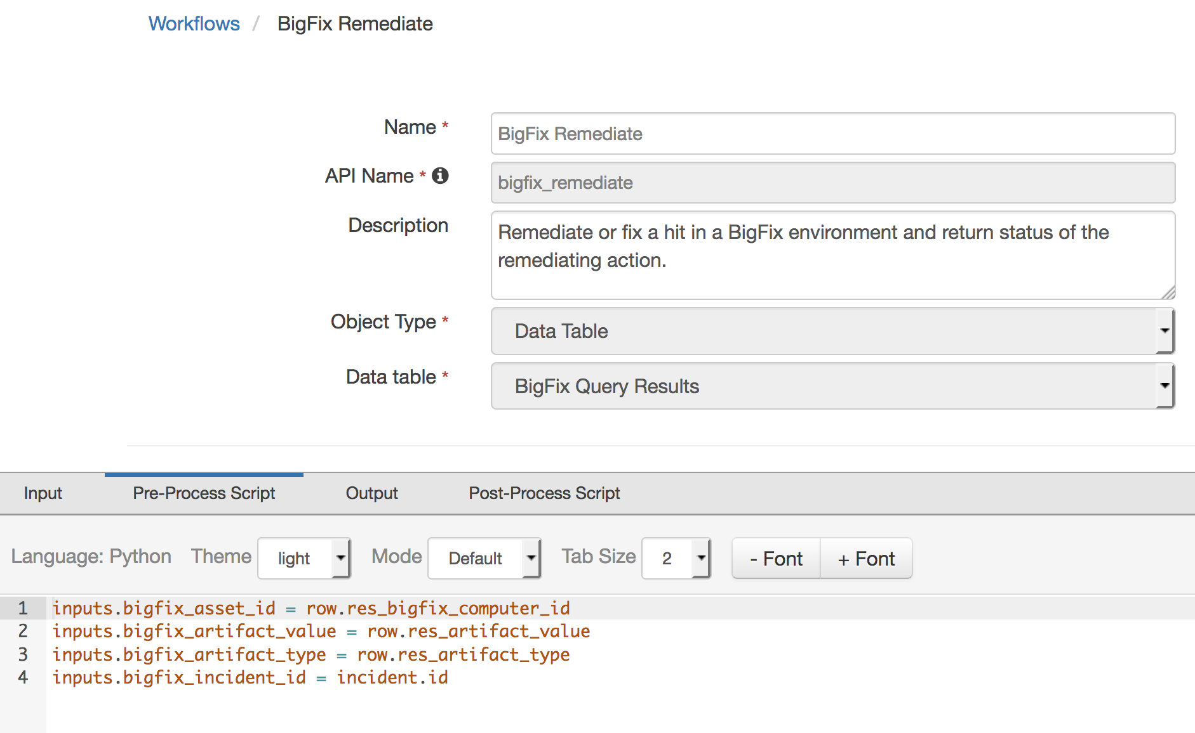

A Menu Item rule called “BigFix Remediate” is also included. This rule calls the workflow. A user can invoke the workflow by right-clicking on this rule from the Actions drop-down or a data table entry for an endpoint with a hit.

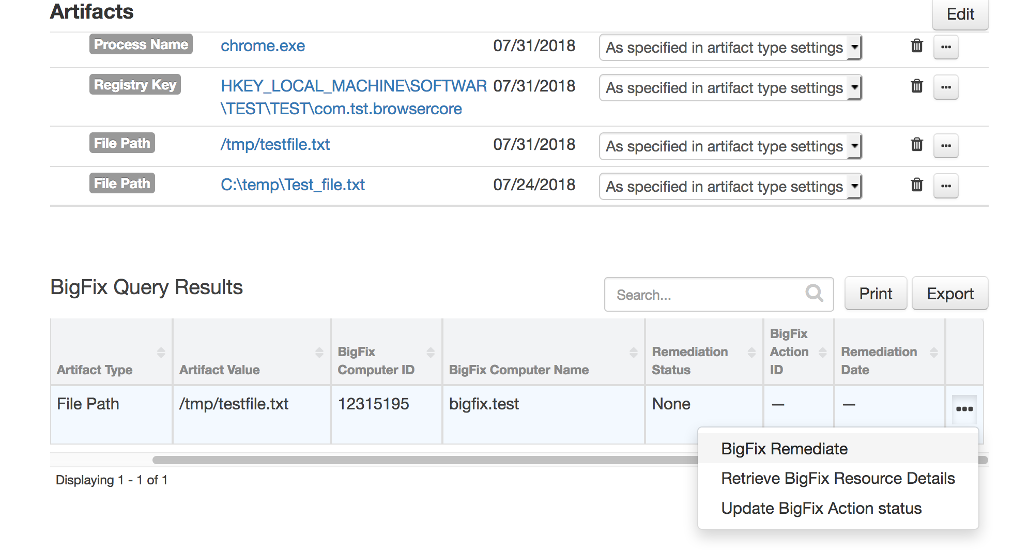

If a remediating BigFix action is successfully created, the entry in the data table “BigFix Query Results” which the workflow was invoked against, is updated with the status, remediation date and action ID.

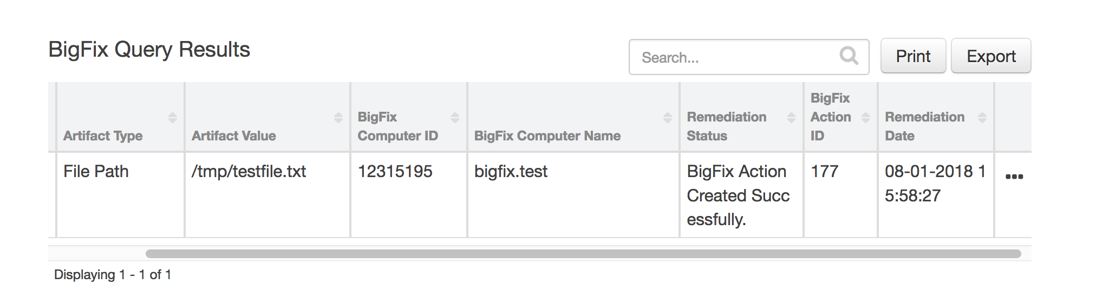

BigFix Action Status

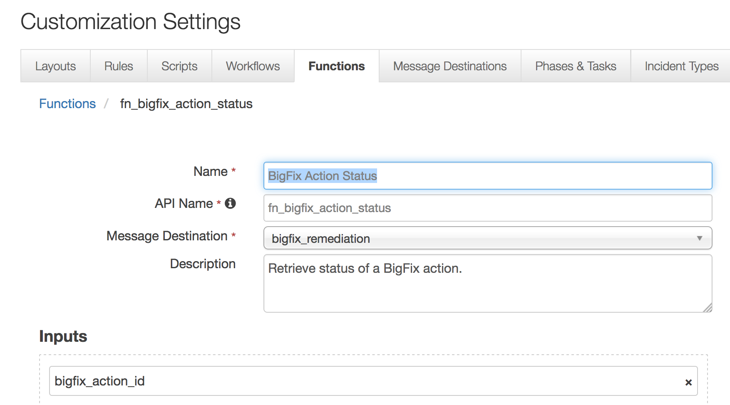

This function takes the following parameter:

* bigfix_action_id – Bigfix action ID
* The example workflow (object type = Data Table) that calls this function is “Update BigFix Action status”.

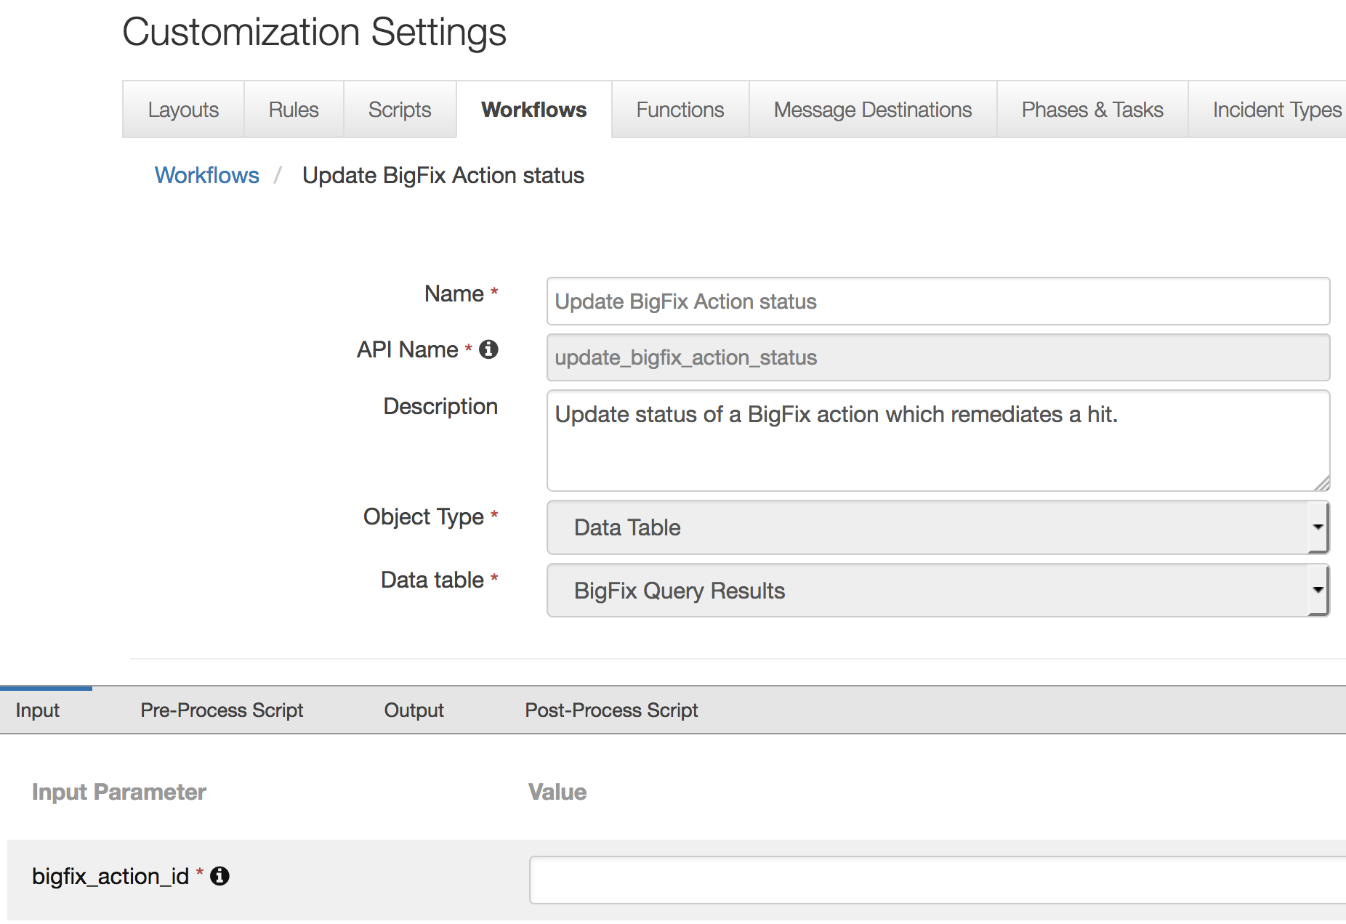

The parameter assignment is done in the Pre-Process Script tab.

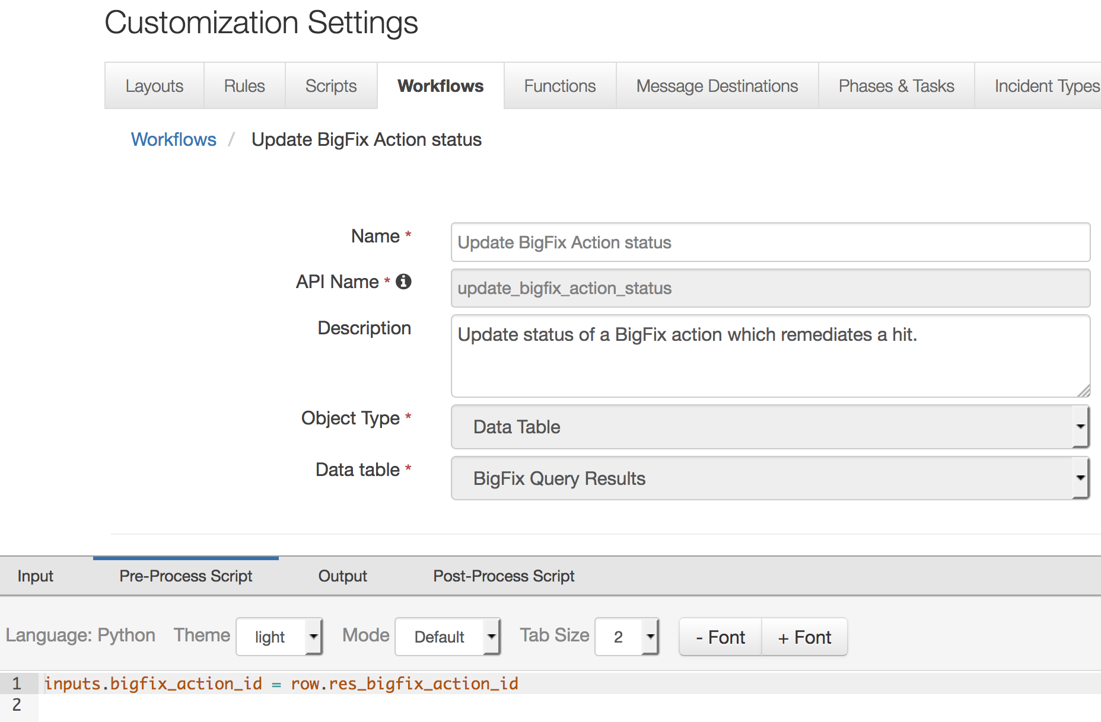

A Menu Item rule called “Update BigFix Action status” is also included. This rule calls the workflow. A user can invoke the workflow by right-clicking on this rule from the Actions drop-down of a data table entry for an endpoint with a hit and where an action ID has been set.

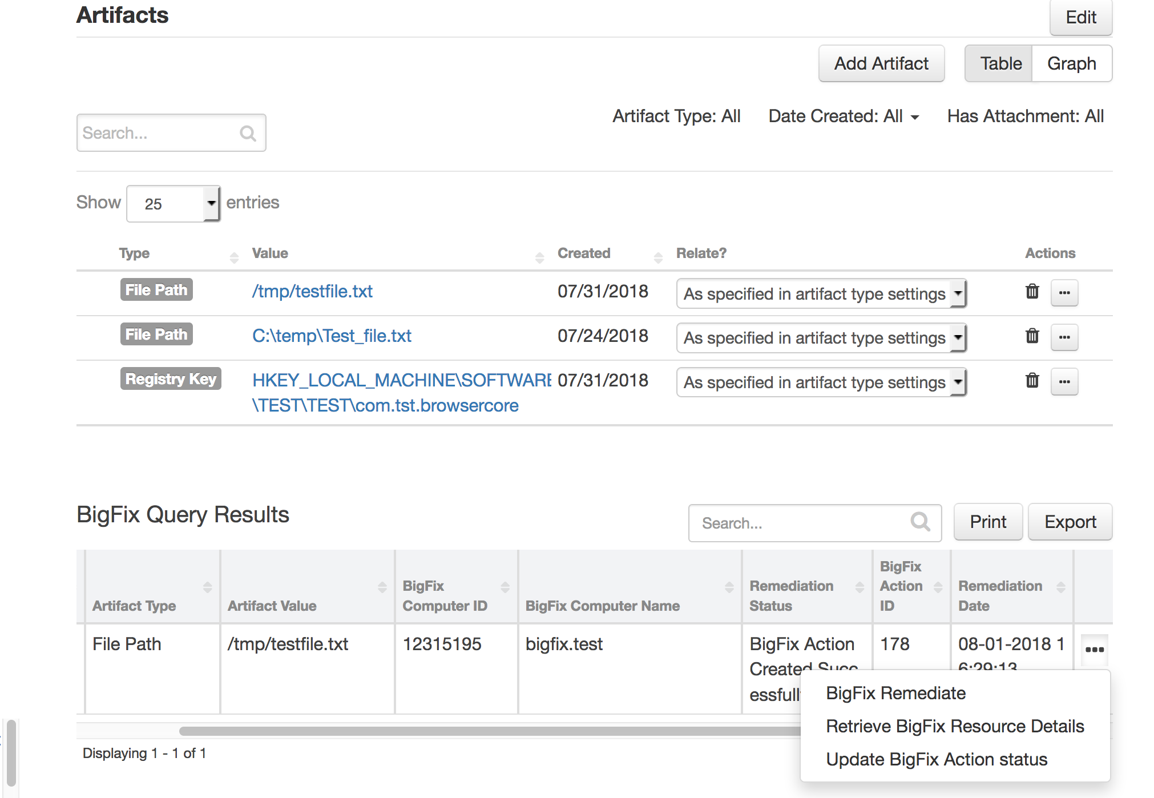

If a remediating BigFix action was executed successfully, the entry in the data table “BigFix Query Results” which the workflow was invoked against, is updated with the new status.

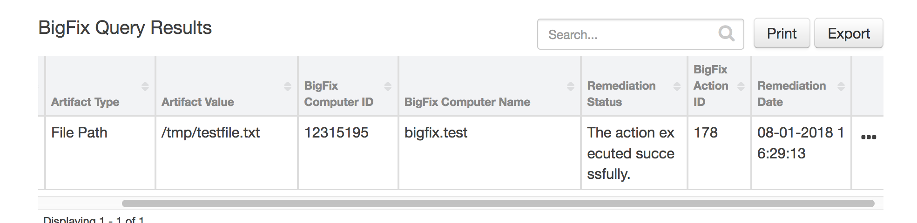

This function is also included in the “BigFix Remediate” workflow and it is invoked aut7omatically as part of that workflow. This would be the more common method of invocation.

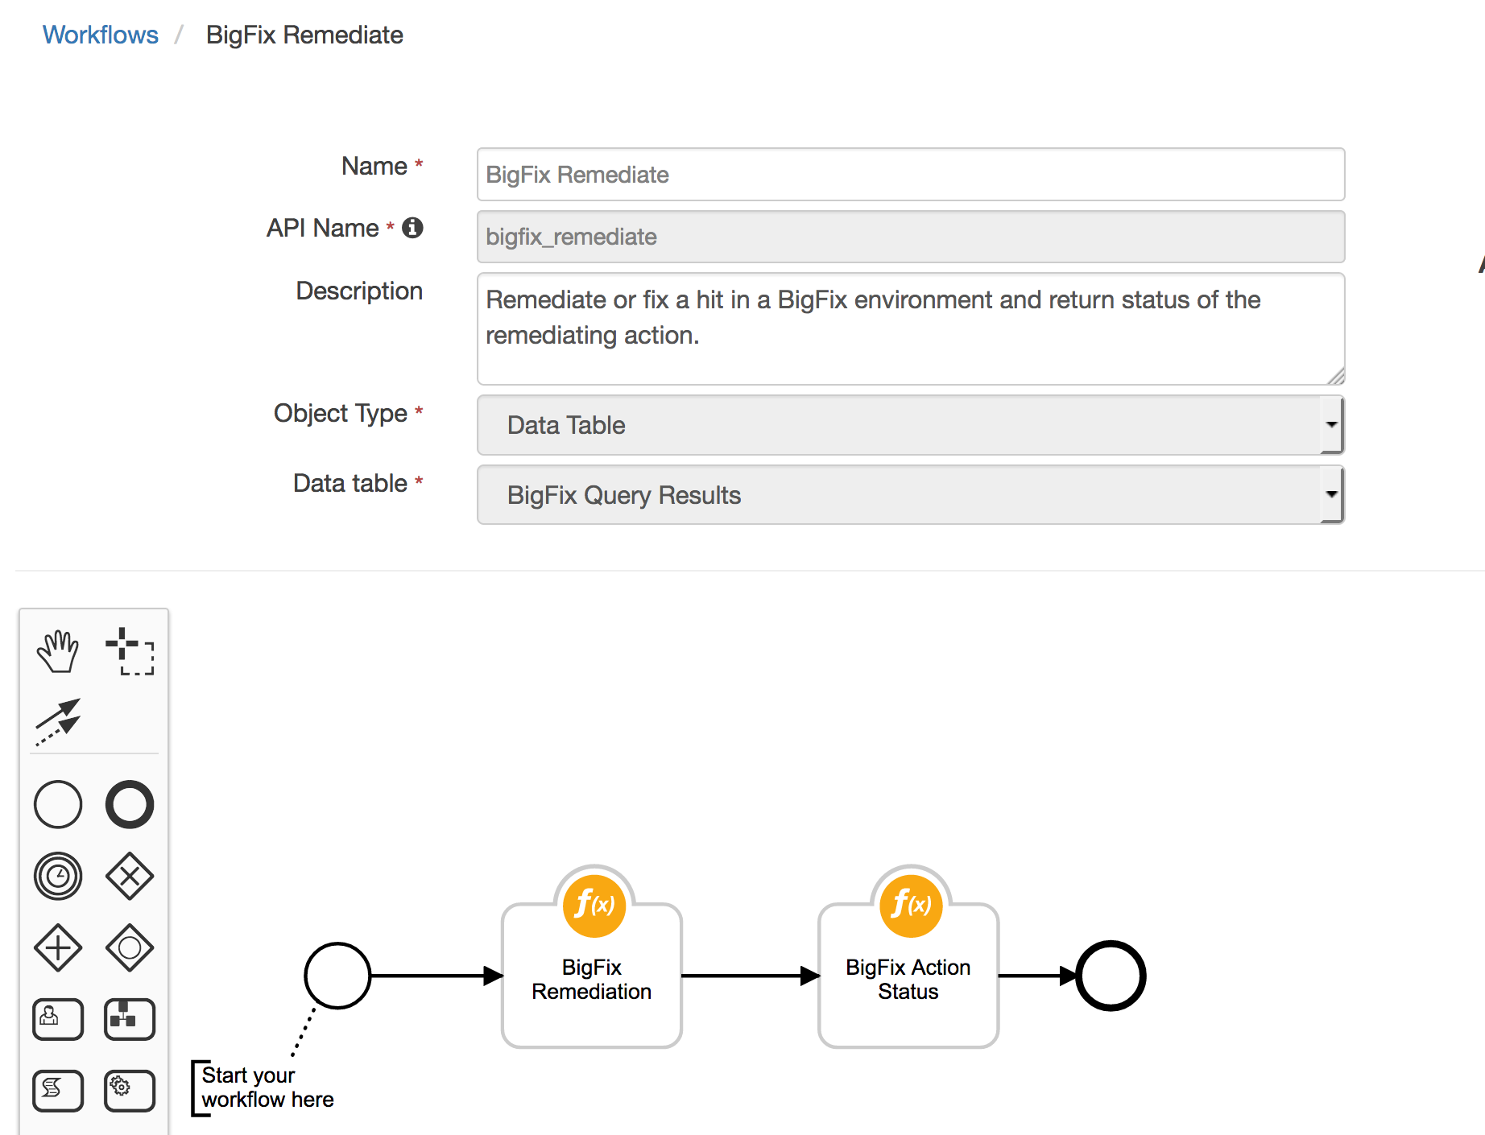

In cases where the “BigFix Remediate” workflow does not receive the status within the specified time, this workflow can be invoked manually at a later time.

BigFix Assets

This function performs a query to fetch BigFix properties of an endpoint with a hit from a BigFix environment.

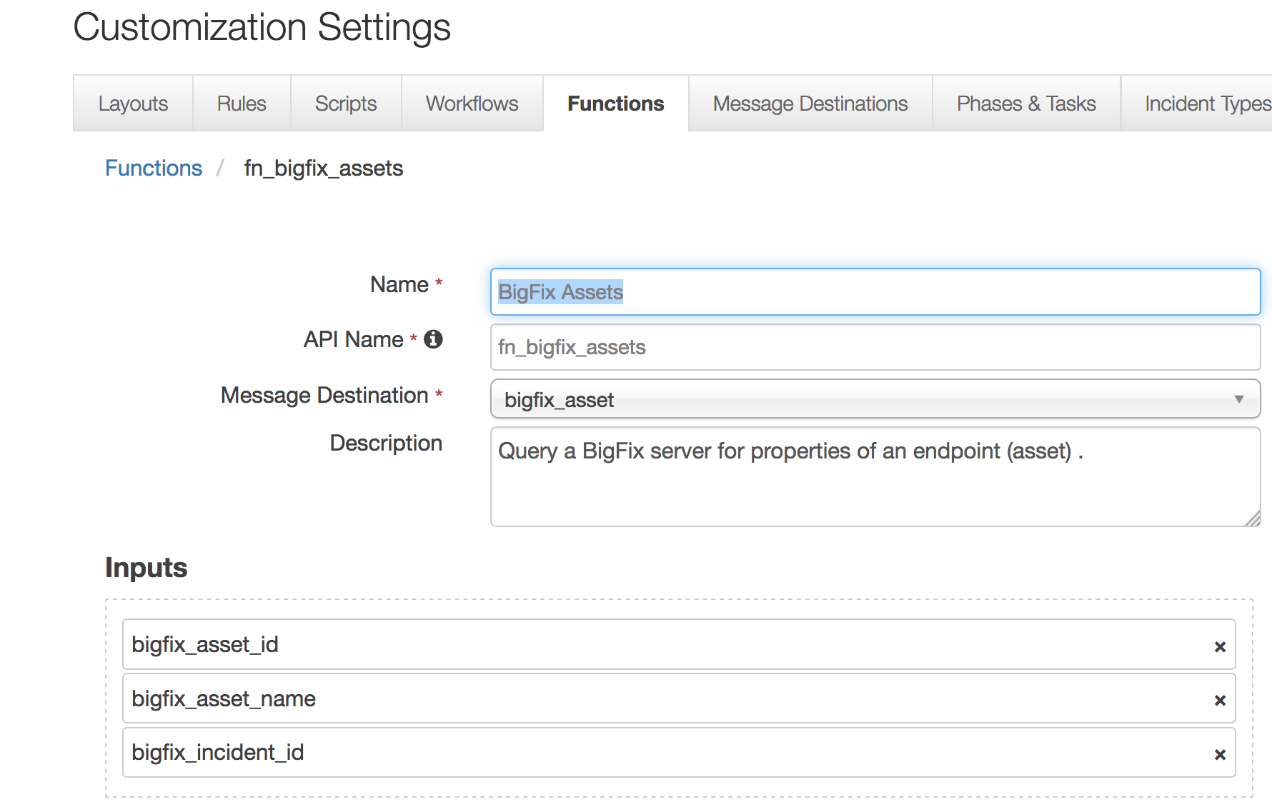

This function takes the following parameter:

* bigfix_asset_id – Bigfix endpoint or asset ID
* bigfix_asset_name - Bigfix endpoint or asset name
* bigfix_incident_id - Resilient incident ID
* The example workflow (object type = Data Table) that calls this function is “Retrieve BigFix Resource Details”.

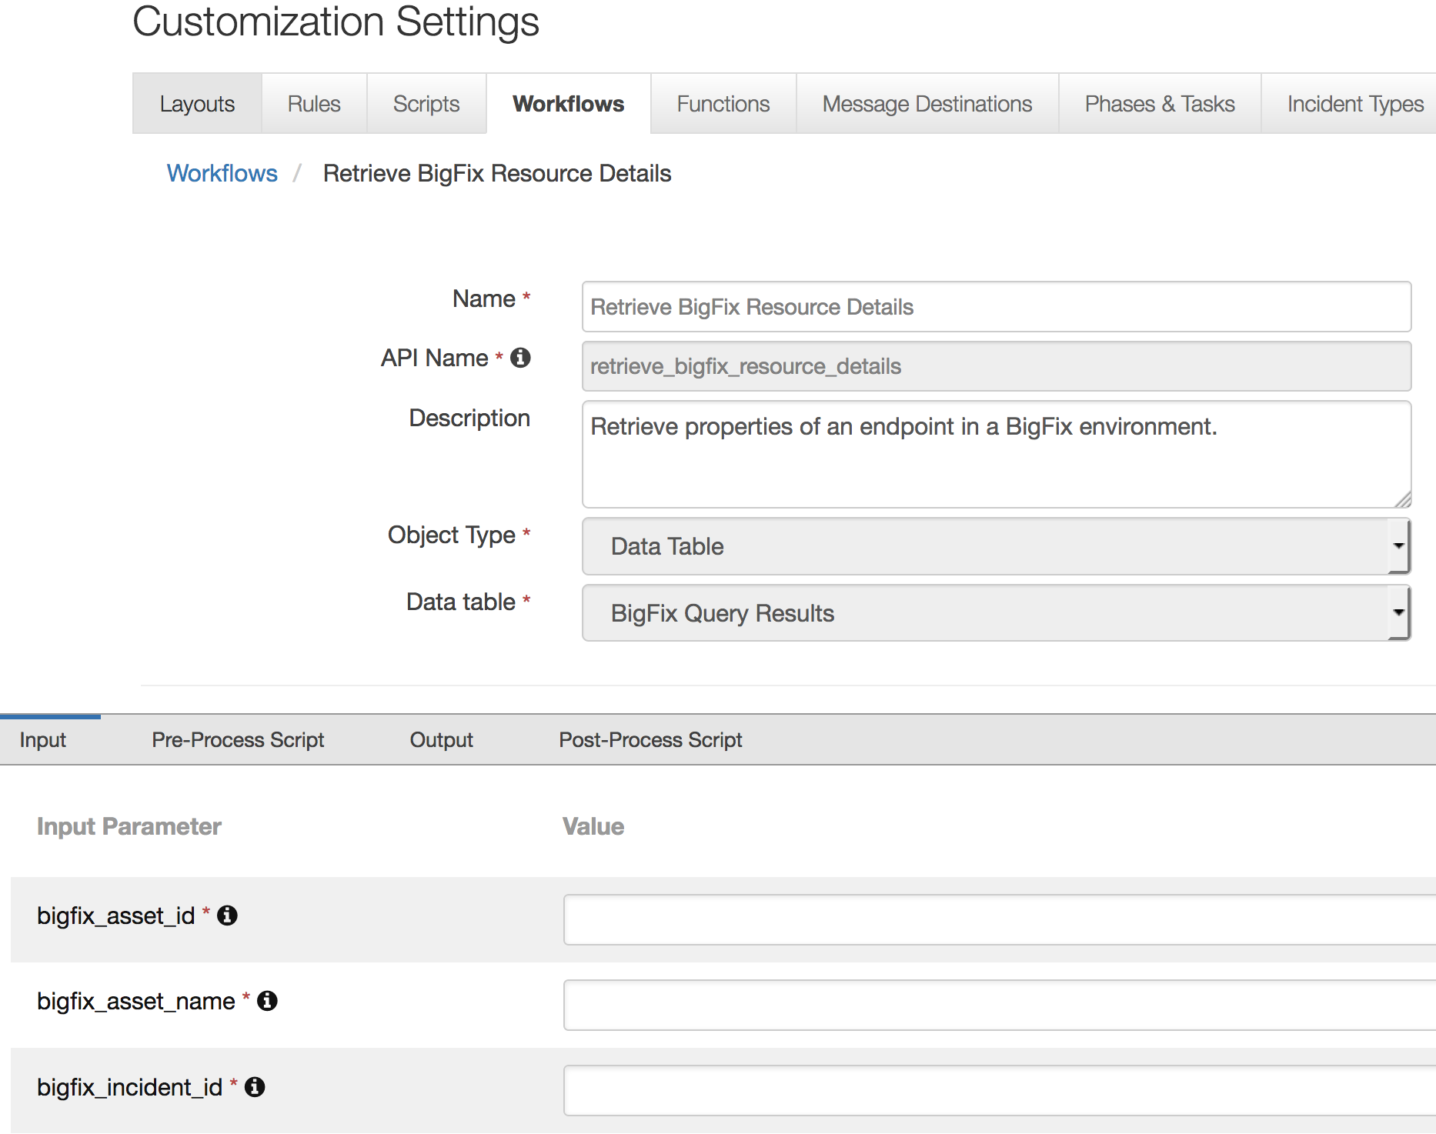

The parameter assignments are done in the Pre-Process Script tab.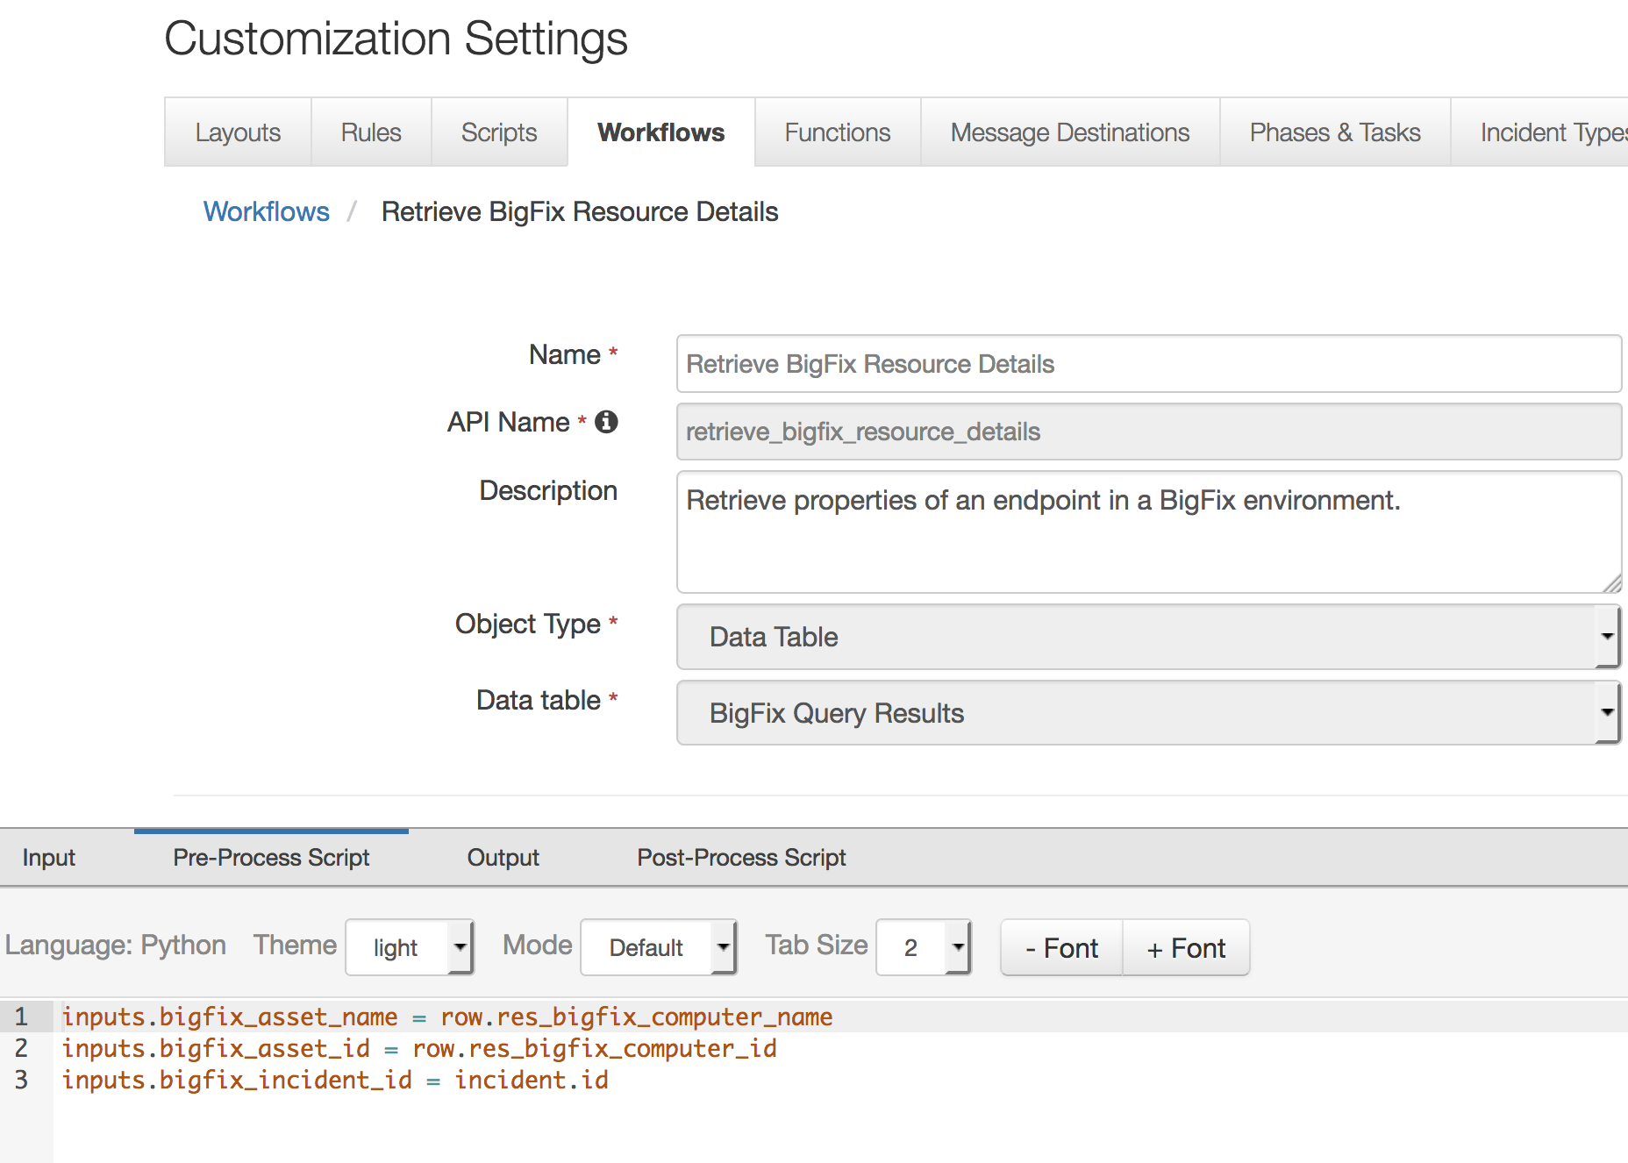

A Menu Item rule called “Retrieve BigFix Resource Details” is also included. This rule calls the workflow. A user can invoke the workflow by right-clicking on this rule from the Actions drop-down of a data table entry for an endpoint with a hit.

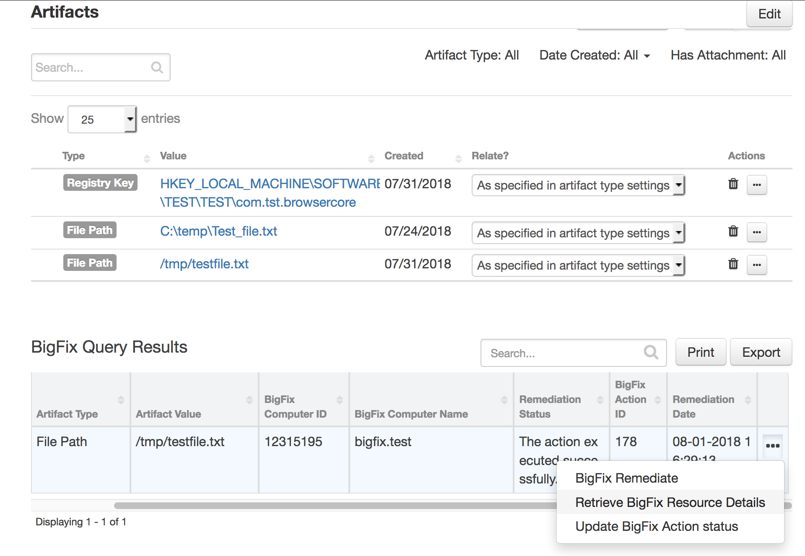

An attachment is added to the incident containing BigFix properties of the targeted endpoint.

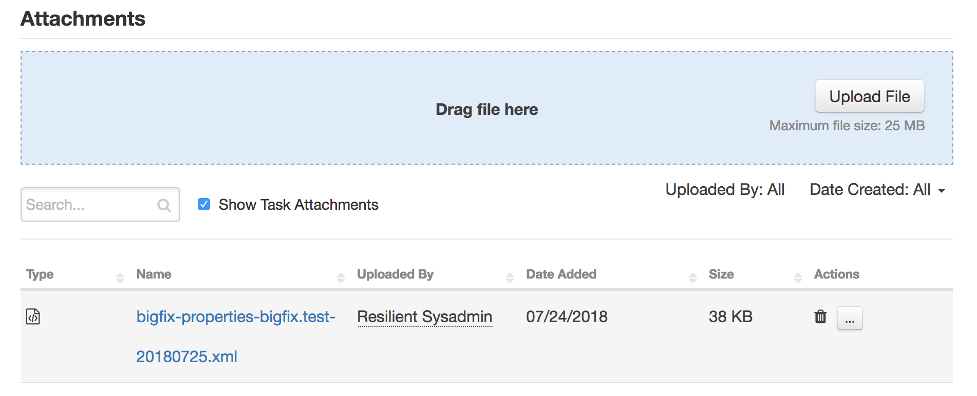

Resilient Platform Configuration

To display query results, users need to manually add the “BigFix Query Results” data table to the Artifacts tab.

1. Navigate to the Customization Settings and select the Layouts tab.
2. Select Artifacts.
3. Drag the “BigFix Query Results” data table to your Artifacts tab.
4. Click Save.

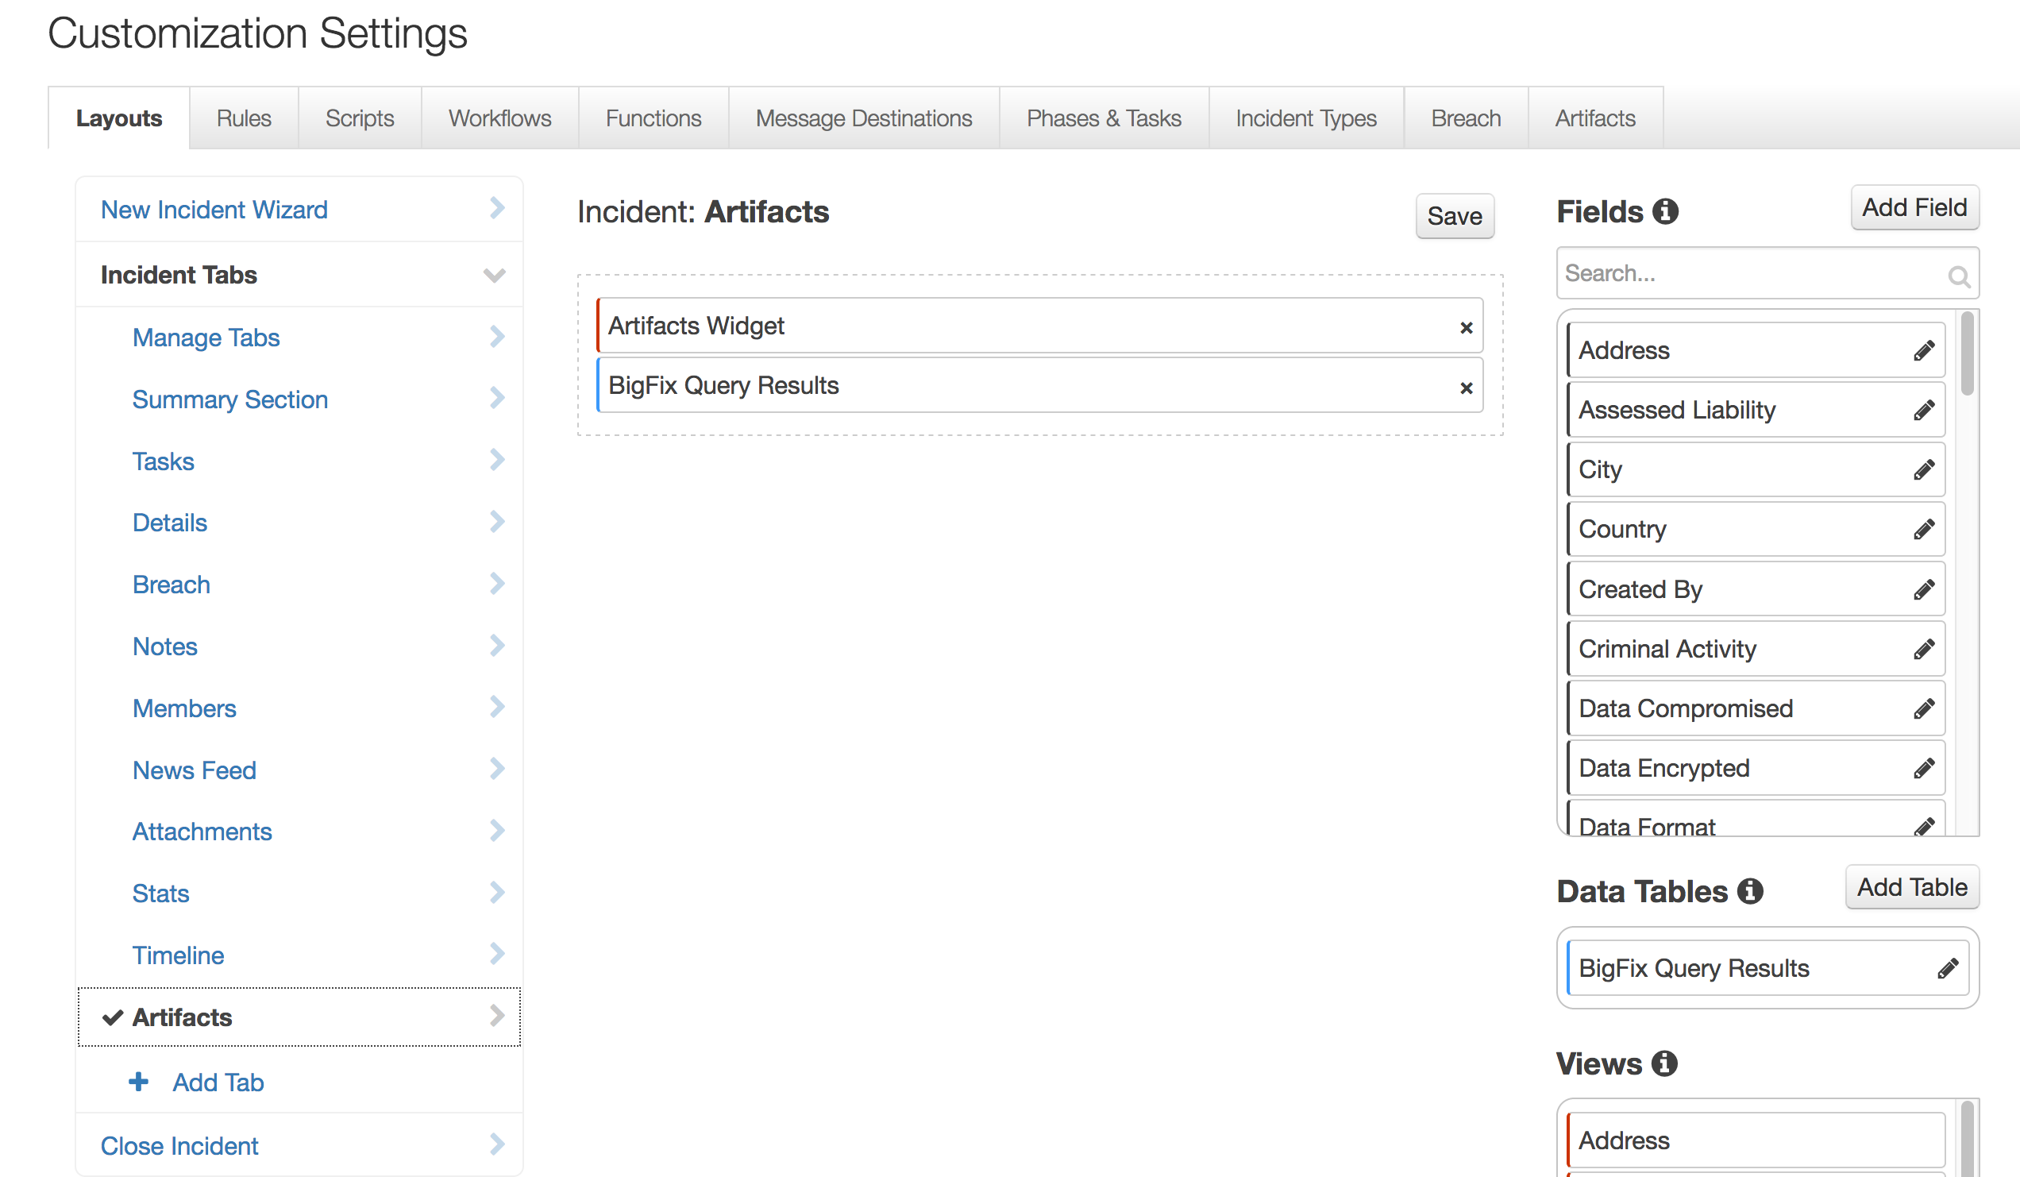

Next are the details about how each function is used in the example workflow and rule after the function package customizations are deployed to the Resilient instance, you can view the functions in the Functions tab in the Resilient platform, as shown in the following screenshots.

Troubleshooting

There are several ways to verify the successful operation of a function.

* Resilient Action Status

When viewing an incident, use the Actions menu to view Action Status. By default, pending and errors are displayed. Modify the filter for actions to also show Completed actions. Clicking on an action displays additional information on the progress made or what error occurred.

* Resilient Scripting Log

A separate log file is available to review scripting errors. This is useful when issues occur in the pre-processing or post-processing scripts. The default location for this log file is: /var/log/resilient-scripting/resilient-scripting.log

* Resilient Logs

By default, Resilient logs are retained at /usr/share/co3/logs. The client.log may contain additional information regarding the execution of functions.

* Resilient-Circuits

The log is controlled in the .resilient/app.config file under the section [resilient] and the property logdir. The default file name is app.log. Each function will create progress information. Failures will show up as errors and may contain python trace statements.

Support

For additional support, contact [support@resilientsystems.com](mailto:support@resilientsystems.com).

Including relevant information from the log files will help us resolve your issue.